**Assignment #2**

**Stats 157 Winter 2018**

Sarah Ruckman

SID: 7194

Luke is a quality control manager for a large computer manufacturing corporation. The corporation receives shipments of computer chips in lots of size 2000. They have become concerned that the quality of the computer chips from the current vendor is sub-quality. Luke decided to randomly sample 225 chips from each shipment for testing. He obtained a random sample of shipments and recorded the data in data file named chips asmt2 w18.xls.

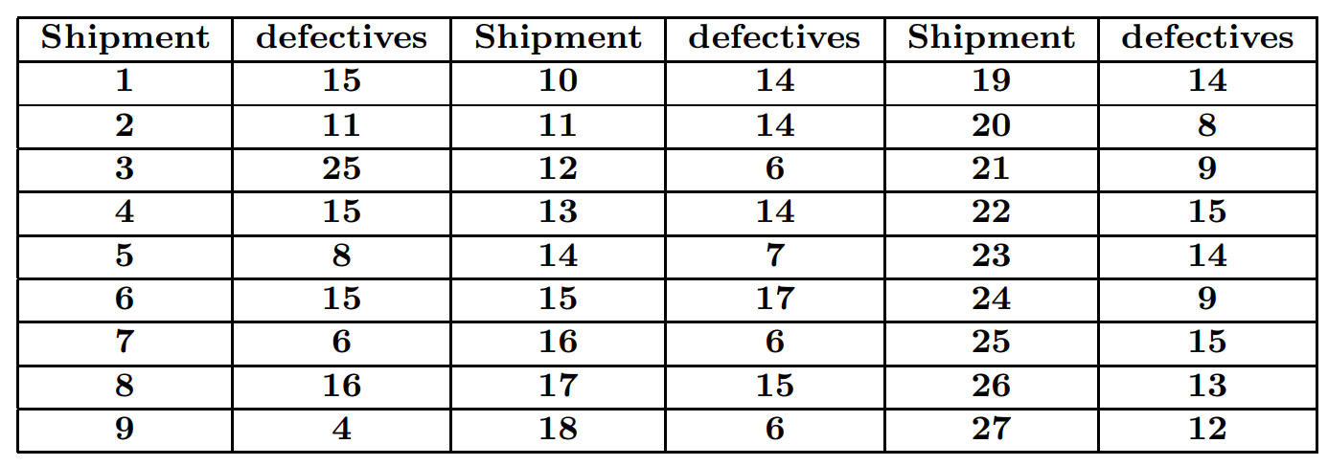

1. Write the appropriate SAS code to read in and print out the data. (4 pts)

**SAS Code:**

/*Set up options and turn off extra graphics*/

options nocenter nodate nonumber ps=**55** ls=**78**;

ods graphics off;

/*Use proc import to read in the data in the excel worksheet

out = name of output SAS dataset

dbms= xls since it is an excel .xls file

replace replaces the directory

sheet = name of sheet

getnames = YES since their is a header in the file */

**proc** **import** out = WORK.chips2

datafile= "C:\Users\sarah\Downloads\chips_asmt2_w18.xls"

dbms = xls replace;

sheet = 'chips';

getnames=YES;

/*Create new temporary SAS dataset called chips*/

**data** chips;

/*Set up titles*/

title1 'Statistics 157';

title2 'Assignment #2';

title3 'Sarah Ruckman';

title4 'Question 1';

/*Use the set command to bring in the data*/

set chips2;

/*Print as check*/

**proc** **print** noobs;

**run**;

**quit**;

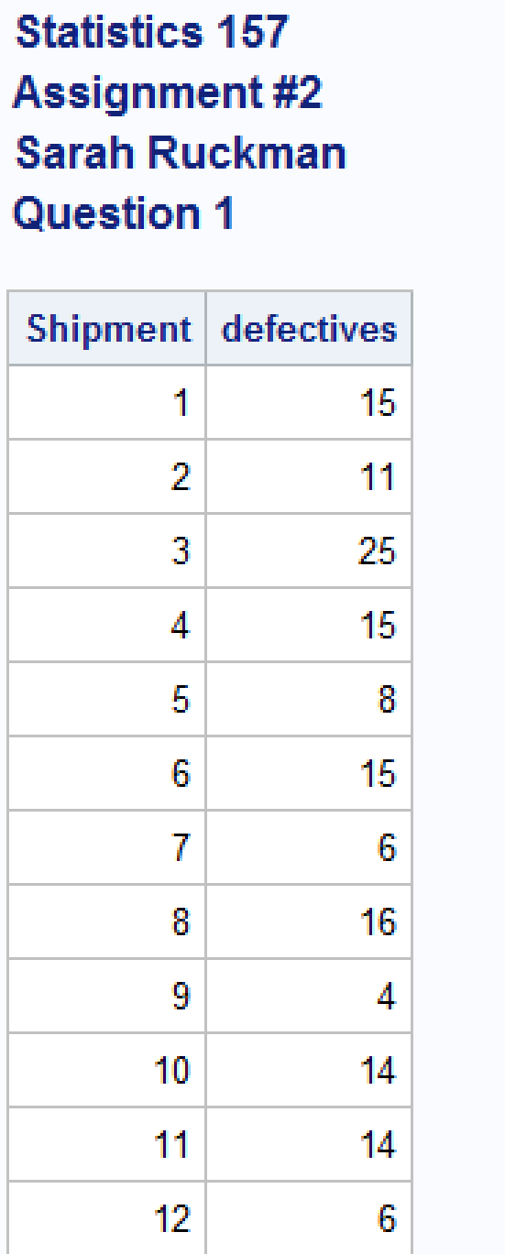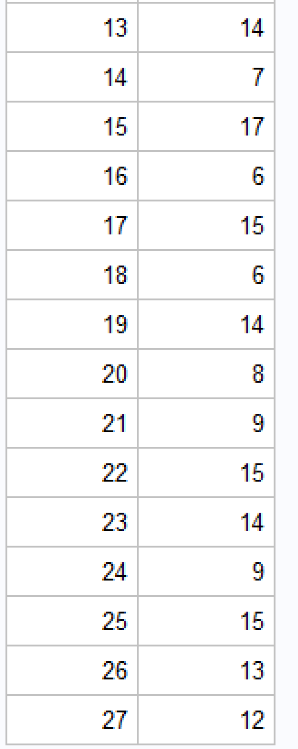

1. Create a one-way table for the number of defective chips per shipment. (3 pts)

**SAS Code:**

/*Set up options and turn off extra graphics*/

options nocenter nodate nonumber ps=**55** ls=**78**;

ods graphics off;

/*Use proc import to read in the data in the excel worksheet

out = name of output SAS dataset

dbms= xls since it is an excel .xls file

replace replaces the directory

sheet = name of sheet

getnames = YES since their is a header in the file */

**proc** **import** out = WORK.chips2

datafile= "C:\Users\sarah\Downloads\chips_asmt2_w18.xls"

dbms = xls replace;

sheet = 'chips';

getnames=YES;

/*Create new temporary SAS dataset called chips*/

**data** chips;

/*Set up titles*/

title1 'Statistics 157';

title2 'Assignment #2';

title3 'Sarah Ruckman';

title4 'Question 1';

/*Use the set command to bring in the data*/

set chips2;

/*Print as check*/

**proc** **print** noobs;

/*Create a one-way table using proc freq and remove percentages and cumulative

values from table using nopercent and nocum*/

**proc** **freq**;

tables defectives/ nopercent nocum;

/*Modify title4*/

title4 'Question 2';

**run**;

**quit**;

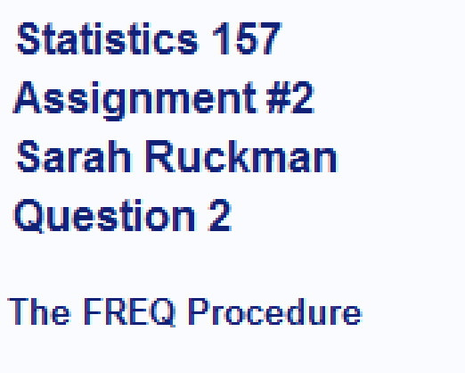

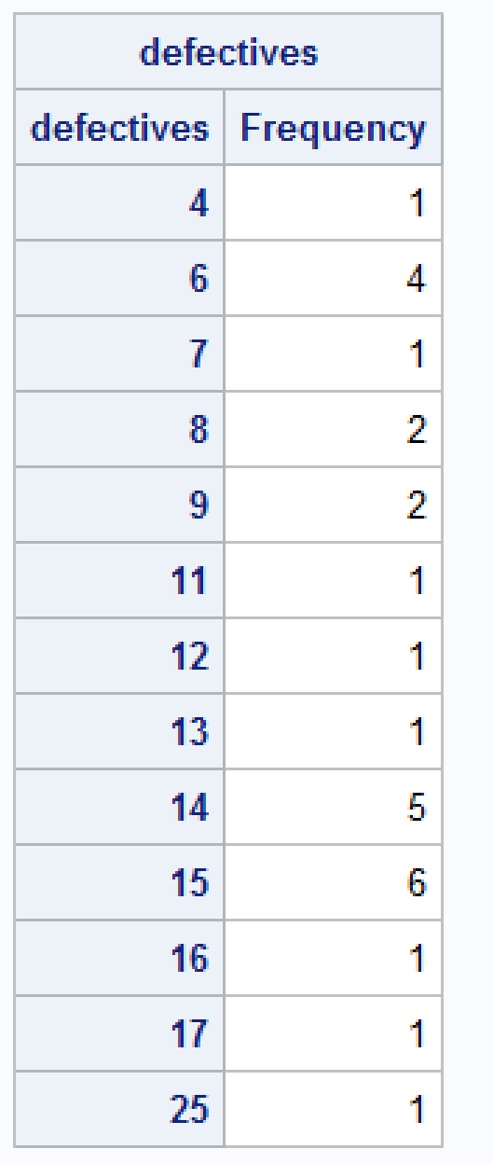

1. Find the total number of defective chips. (2 pts)

**SAS Code:**

/*Set up options and turn off extra graphics*/

options nocenter nodate nonumber ps=**55** ls=**78**;

ods graphics off;

/*Use proc import to read in the data in the excel worksheet

out = name of output SAS dataset

dbms= xls since it is an excel .xls file

replace replaces the directory

sheet = name of sheet

getnames = YES since their is a header in the file */

**proc** **import** out = WORK.chips2

datafile= "C:\Users\sarah\Downloads\chips_asmt2_w18.xls"

dbms = xls replace;

sheet = 'chips';

getnames=YES;

/*Create new temporary SAS dataset called chips*/

**data** chips;

/*Set up titles*/

title1 'Statistics 157';

title2 'Assignment #2';

title3 'Sarah Ruckman';

title4 'Question 1';

/*Use the set command to bring in the data*/

set chips2;

/*Print as check*/

**proc** **print** noobs;

/*Create a one-way table using proc freq and remove percentages and cumulative

values from table using nopercent and nocum*/

**proc** **freq**;

tables defectives/ nopercent nocum;

/*Modify title4*/

title4 'Question 2';

/*Use proc means to find the sum of the data*/

**proc** **means** sum;

var defectives;

/*Modify title 4*/

title4 'Question 3';

**run**;

**quit**;

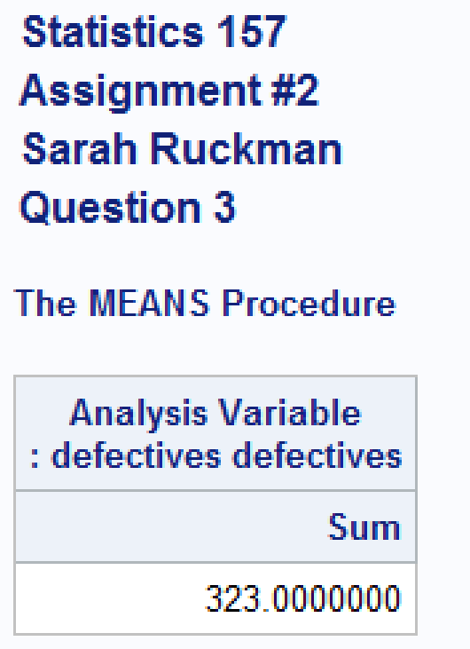

**The total number of defective chips is 323.**

1. Find the average number of defective chips per shipment. (2 pts)

**SAS Code:**

/*Set up options and turn off extra graphics*/

options nocenter nodate nonumber ps=**55** ls=**78**;

ods graphics off;

/*Use proc import to read in the data in the excel worksheet

out = name of output SAS dataset

dbms= xls since it is an excel .xls file

replace replaces the directory

sheet = name of sheet

getnames = YES since their is a header in the file */

**proc** **import** out = WORK.chips2

datafile= "C:\Users\sarah\Downloads\chips_asmt2_w18.xls"

dbms = xls replace;

sheet = 'chips';

getnames=YES;

/*Create new temporary SAS dataset called chips*/

**data** chips;

/*Set up titles*/

title1 'Statistics 157';

title2 'Assignment #2';

title3 'Sarah Ruckman';

title4 'Question 1';

/*Use the set command to bring in the data*/

set chips2;

/*Print as check*/

**proc** **print** noobs;

/*Create a one-way table using proc freq and remove percentages and cumulative

values from table using nopercent and nocum*/

**proc** **freq**;

tables defectives/ nopercent nocum;

/*Modify title4*/

title4 'Question 2';

/*Use proc means to find the sum of the data*/

**proc** **means** sum;

var defectives;

/*Modify title 4*/

title4 'Question 3';

/*Use proc means to find the mean of the data*/

**proc** **means** mean;

var defectives;

/*Modify title 4*/

title4 'Question 4';

**run**;

**quit**;

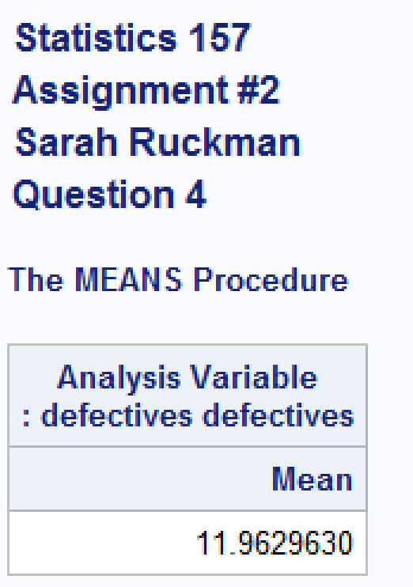

**The average number of defectives is 11.9629630 chips.**

1. Create a 3D vertical bar chart representing the number of defective chips per shipment. Be creative, but use a prism shape. (4 pts)

**SAS Code:**

/*Set up options and turn off extra graphics*/

options nocenter nodate nonumber ps=**55** ls=**78**;

ods graphics off;

/*Use proc import to read in the data in the excel worksheet

out = name of output SAS dataset

dbms= xls since it is an excel .xls file

replace replaces the directory

sheet = name of sheet

getnames = YES since their is a header in the file */

**proc** **import** out = WORK.chips2

datafile= "C:\Users\sarah\Downloads\chips_asmt2_w18.xls"

dbms = xls replace;

sheet = 'chips';

getnames=YES;

/*Create new temporary SAS dataset called chips*/

**data** chips;

/*Set up titles*/

title1 'Statistics 157';

title2 'Assignment #2';

title3 'Sarah Ruckman';

title4 'Question 1';

/*Use the set command to bring in the data*/

set chips2;

/*Print as check*/

**proc** **print** noobs;

/*Create a one-way table using proc freq and remove percentages and cumulative

values from table using nopercent and nocum*/

**proc** **freq**;

tables defectives/ nopercent nocum;

/*Modify title4*/

title4 'Question 2';

/*Use proc means to find the sum of the data*/

**proc** **means** sum;

var defectives;

/*Modify title 4*/

title4 'Question 3';

/*Use proc means to find the mean of the data*/

**proc** **means** mean;

var defectives;

/*Modify title 4*/

title4 'Question 4';

/*Use proc gchart to create a vertical bar chart that is 3d*/

**proc** **gchart**;

/*Set up output

rotate rotates the text

h = height of the font c = color of the text

f = font caxis = color of the axis cfr = color of graph/chart background frame

coutline = color of the outline shape = shape of bars

ctext = color of text within chart/graph*/

title rotate=**15** f=swiss h=**6** c=teal 'Defective Chips per Shipment';

var3d defectives / caxis=blue cfr = verylightpurplishblue

coutline = verydarkblue shape =prism ctext = purple;

**run**;

**quit**;



